**Practical no. 5**

**FS19CO042**

**Aim:** Connect computers in Network using given topology with wired media.

**Tool used:** Cisco Packet tracer student software.

**Required components:** PCs, Laptops, switches

**Theory and steps:**

Topologies:

1. **Star topology**

Physical star topology uses a central device or controller with drop cables extending in all direction. The devices are not directly linked to one another. Each network device is connected via point-to-point link to central device called ‘HUB’ or ‘Switch’ multipoint repeater or concentrator. The controller acts as an exchange: If one device wants to send data to another, it sends the data to the controller, which then relays the data to the other connected device. When network expansion is expected and a greater reliability is expected then star topology is needed.

Logical Overview:

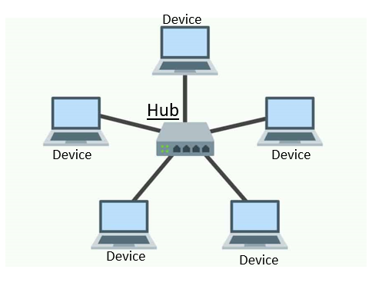

Working of Star topology:

Each PC on star network communicate with central hub or switch that resends the message either to all the PC’s (in a broadcast star network) or only to the destination PC (in a switched star network) when the communication between two nodes is to occur a complete circuit is dedicated to the connection for duration of call. The hub in a broadcast star network can be active or passive.

An active hub regenerates the electrical signal and sends it to all the computers

connected to it. This type of hub is often called a multipoint repeater. Active hubs and switches require electrical power to run; a passive hub such as wiring panel or patch block merely at as a connection point and does not amplify or regenerate the signal. Passive hub doesn’t require electrical power to run.

E.g.: - Ethernet to base t is a popular network based on star topology.

Advantages:

* 1. Addition, Moving and deletion involves only one connection between that device and hub
  2. When the capacity of central hub is exceeded you can replace it with one that has larger number of ports to plug lines into new hub
  3. The center of the star network is a good place to diagnose network faults, intelligent hub (the hub with microprocessor) also provide for centralize monitoring and management of network.
  4. Single PC failures do not necessarily bring down whole star network. The hubs can detect a network fall and isolate the defected PC or network cable and allow the rest of the network to continue operating.
  5. You can use several cable types in the same network with a hub that can accommodate multiple cable types.

Disadvantages:

1. If the central hub fails the whole network fails to operate.
2. Many star networks requires a devices at the central point to rebroadcast or switched network traffic.
3. It cost more to cable a star networks because all the network cables must be pulled to one central point requiring more cable than other networking topologies.

Steps for creating a star topology in Cisco Packet tracer:

1. Select Switches category from Devices section. Select suitable switch model depending on no. of devices to connect.  
   For example, Switch 2950-24.  
   Drop this switch in the logical view.  
     
   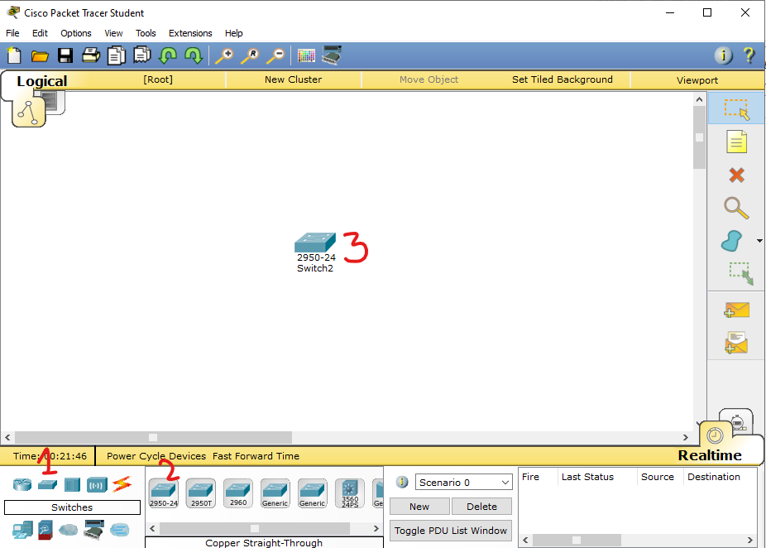
2. Select End devices category from Devices section. Select desired end devices that allow wired connectivity.  
   For example, PC or Laptop. Drop this in logical view.  
   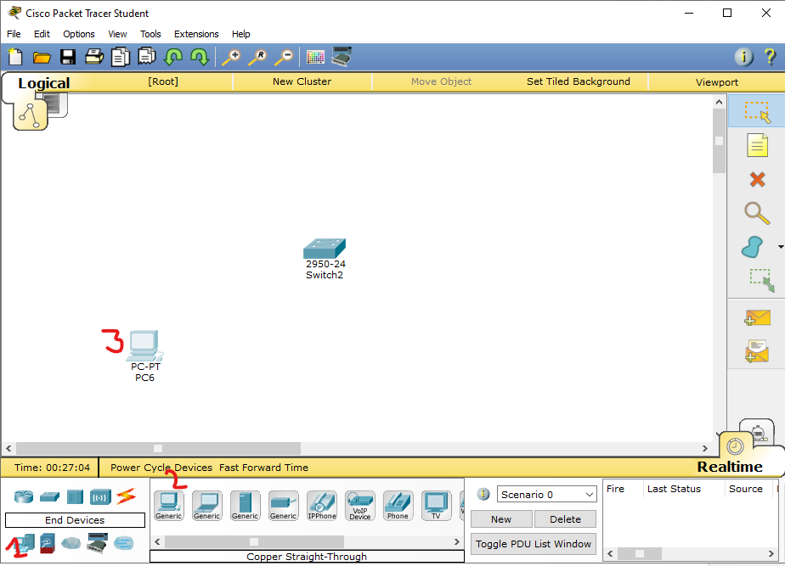  
     
   Similarly add more no of devices as desired to achive layout similar to following diagram:  
     
   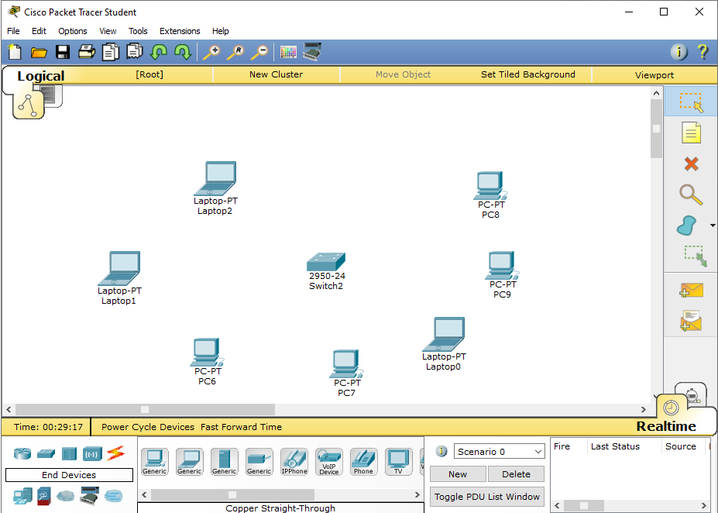
3. Connecting devices  
   From Connections section of Devices select Copper Straight-through cable. Click on any end device and select Fast Ethernet port.  
   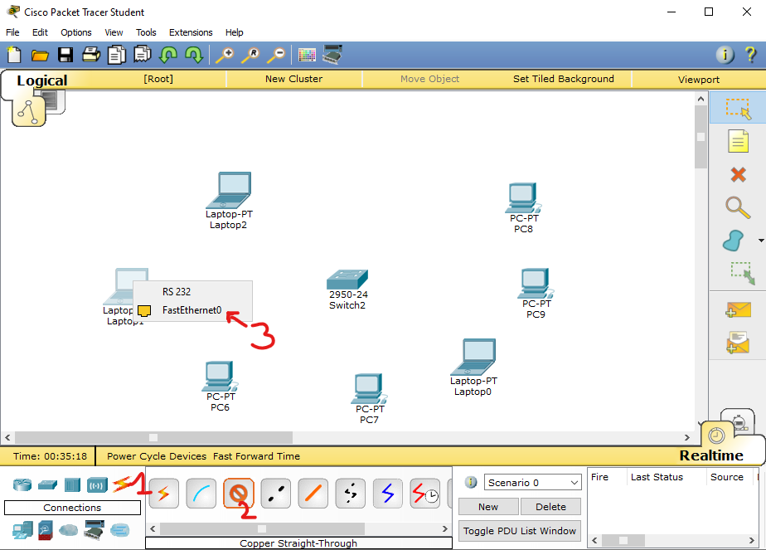  
     
   Now, click on switch and select one of the Fast Ethernet ports  
     
   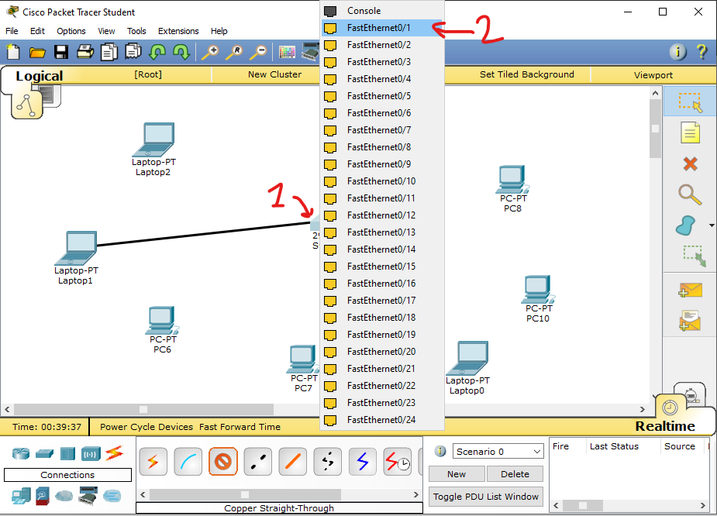

Similarly connect other end devices to the switch  
  
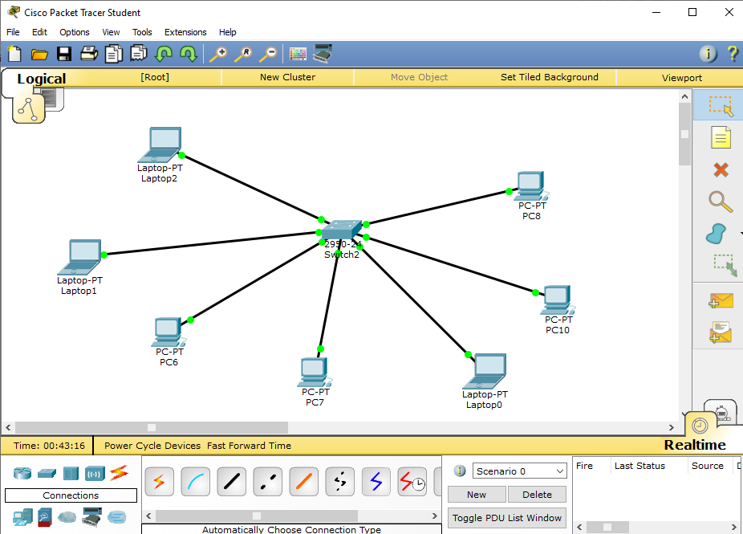

1. **Mesh topology**

In a mesh topology every device has dedicated point-to-point link to every other device. The term dedicated means that the link carries only between the two devices it connects. A fully connected mesh network has n (n-1)/2 physical connections to link devices.

To accommodate that many links every device on the network must have (n-1) output ports because each device requires an interface for every other on the network.

Mesh topology are not usually practical. In addition unless each station frequently sends signal to all the other stations and excessive amount of network bandwidth is wasted.

Mesh gets unmanageable beyond a very small number of devices. Most mesh topology networks are not true mesh networks.

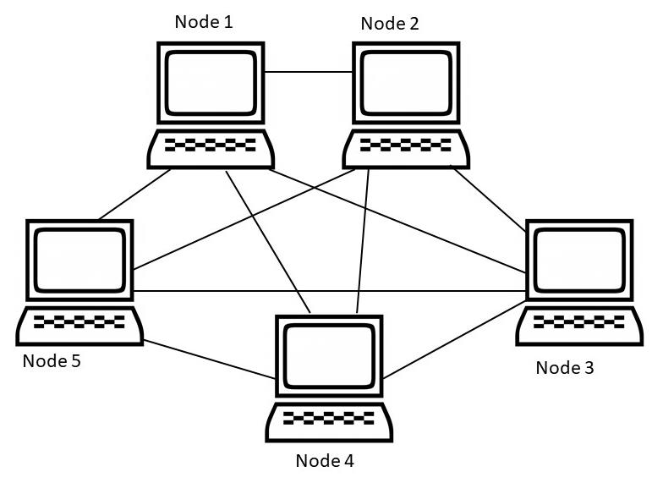Logical overview:

Mesh topology N/w become more difficult to install as the no. of devices increases because of the sheer quantity of connections that must be made. A true mesh topology of seven devices would require 21 connections and six I/O ports.

Advantages:-

* 1. The use of dedicated links guaranties that connections can carry its own data load. Thus eliminating the traffic problem that can occur when links must be shared by multiple devices.
  2. Mesh topology is Robust (strong) if one link becomes unusable. It doesn’t incapacitate the entire n/w.
  3. Another advantage is privacy and security when every message sent travels along a dedicated line only the intended recipients sees it. Physical boundaries prevent other users from gaining access to message.
  4. Point to point link make fault identification and fault isolation easy. Traffic can be routed to avoid links with respected problems. This facility enables the n/w manager to discover the precise location of the fault and aids it finding its cause and solution.
  5. Extremely fault tolerant.
  6. It is more reliable compare to other topologies.
  7. In case of heavy traffic data can be routed around busy root.

Disadvantages:

* 1. As it involves a lot of connection. The total no. of physical links and the no. of I/O ports require to connect will be more and hence is prohibitively expensive.
  2. Difficult to install and reconfigure specially as no. of devices increases.
  3. Hardware required to connect each device is highly expensive.
  4. The sheer bulk of the wiring can be greater than the available space (walls, ceiling and floors) can accommodate. For these reasons a mesh topology is usually implemented in a limited fashion

Steps for creating a mesh topology in Cisco Packet tracer:

1. 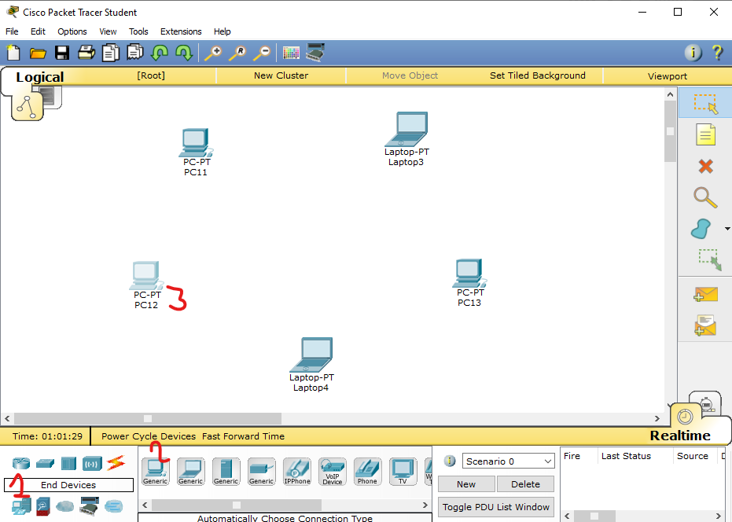Select End devices category from Devices section. Select desired end devices that allow wired connectivity.  
   For example, PC or Laptop. Drop this in logical view. Add desired no. of devices, eg. 5

1. Connections  
   Since a PC can’t connect multiple other devices through fast ethernet, connect an individual switch to each end device so that it can be connected to multiple other switches.

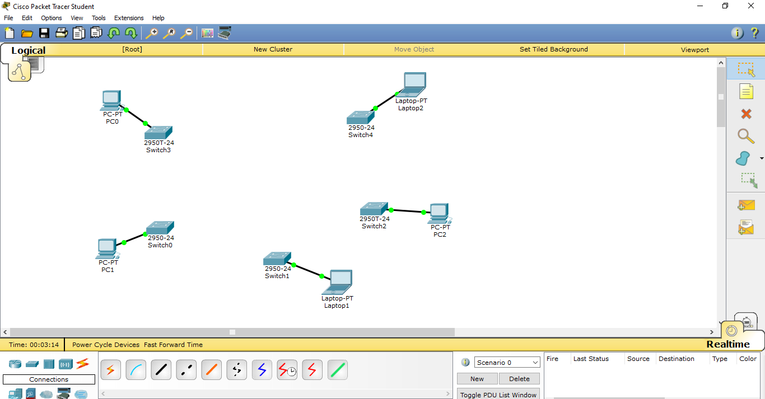

1. 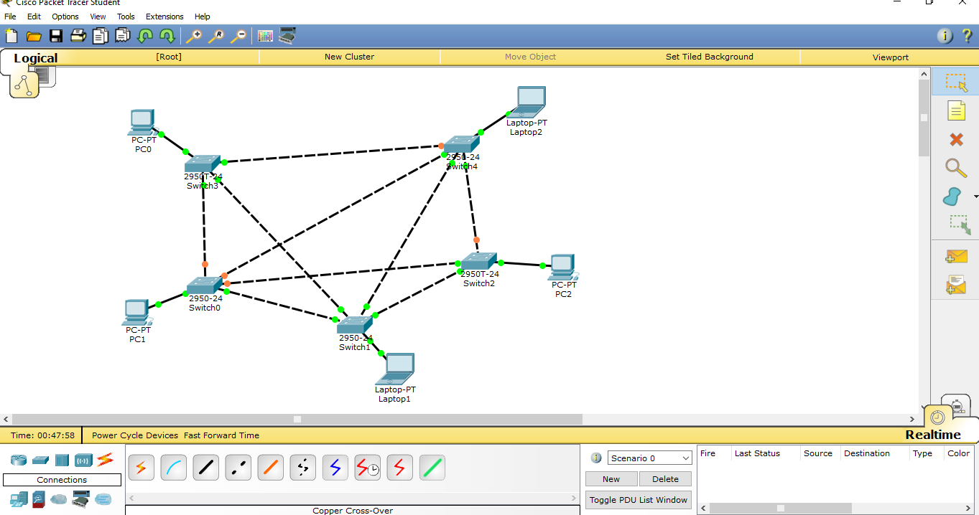Connect a switch to every other switch, so that in the example every switch is connected to 4 switches.  
   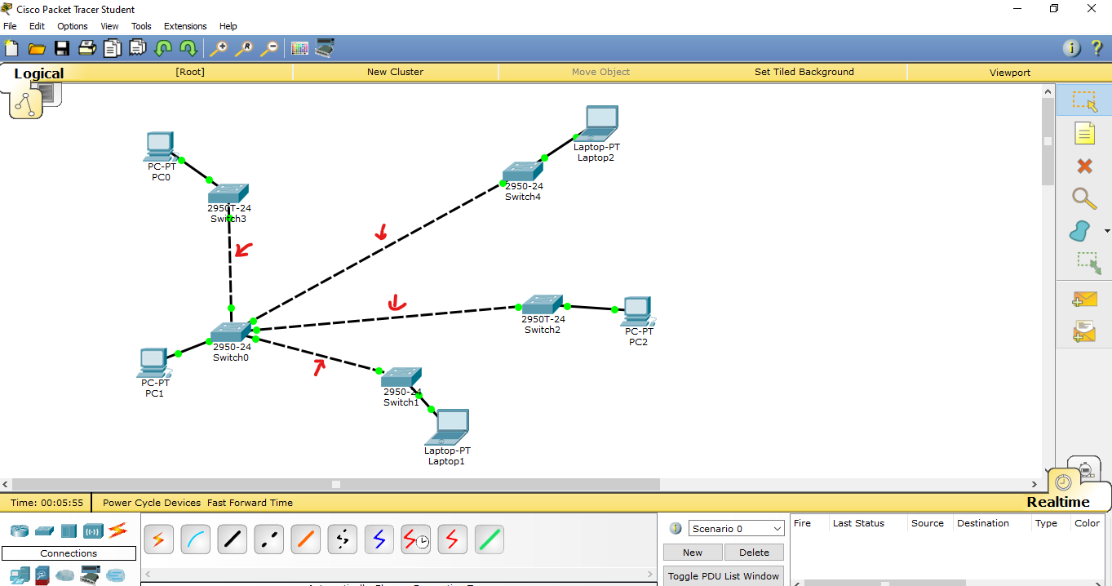  
     
   Similarly, connect all switches, such that every switch is connected to every other switch.  
   Final topology:

**Conclusion:** Thus we understood and connected computers in Star and mesh topologies using wired media.